CDE

Workshop

Student

Guide

# Introduction

This document aims to introduce to the features of **CDE**, the Data Engineering Data Service of Cloudera Data Platform (**CDP**).

In this workshop:

* You will run sample spark jobs as ad-hoc jobs.

○ PySpark

○ Spark-scala

* You will run the same spark jobs as part of a schedule.
* With the help of Airflow, you will orchestrate a set of Spark jobs and trigger them as a flow.
* You will use CDE CLI to trigger the jobs from terminal/powershell.
* You will see the data lineage using Atlas and witness the auto-scaling capabilities of the CDE Data service.

# Prerequisites

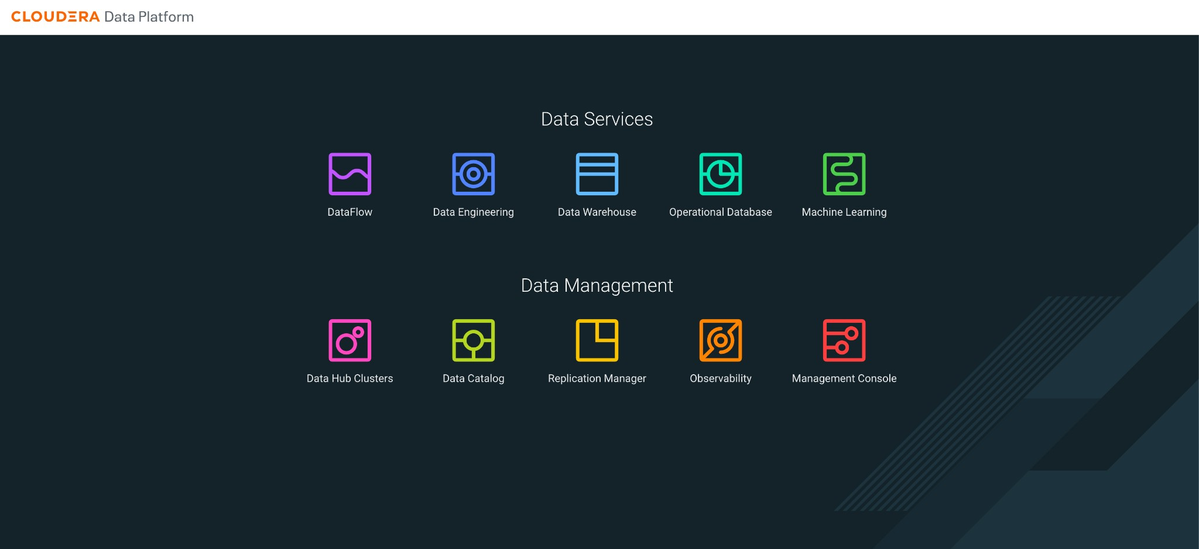

## 

## Download the resources

There are two ways in which you can access the scripts/resources.

* Download src code and data files from CDE Folder

<https://github.com/amishra1006/CDP-Enablement-session-2024.git>

cde_src contains 2 python file that wil be used to run jobs

cde_res_files.zip contain 2 csv files that will be used by job to read data and perform DE operations

## Upload data file to ADLS data container or S3 data bucket

Eg path :- abfs://data@<storage account>.dfs.core.windows.net/cde_workshop/*.csv

## Update the script files(.py) to use the above path under below highlighted section

● Go through each script and update the necessary values as mentioned in the script.

○ For all the scripts, update the username field with the username that you have been assigned to. You will find this at the starting of the script itself.

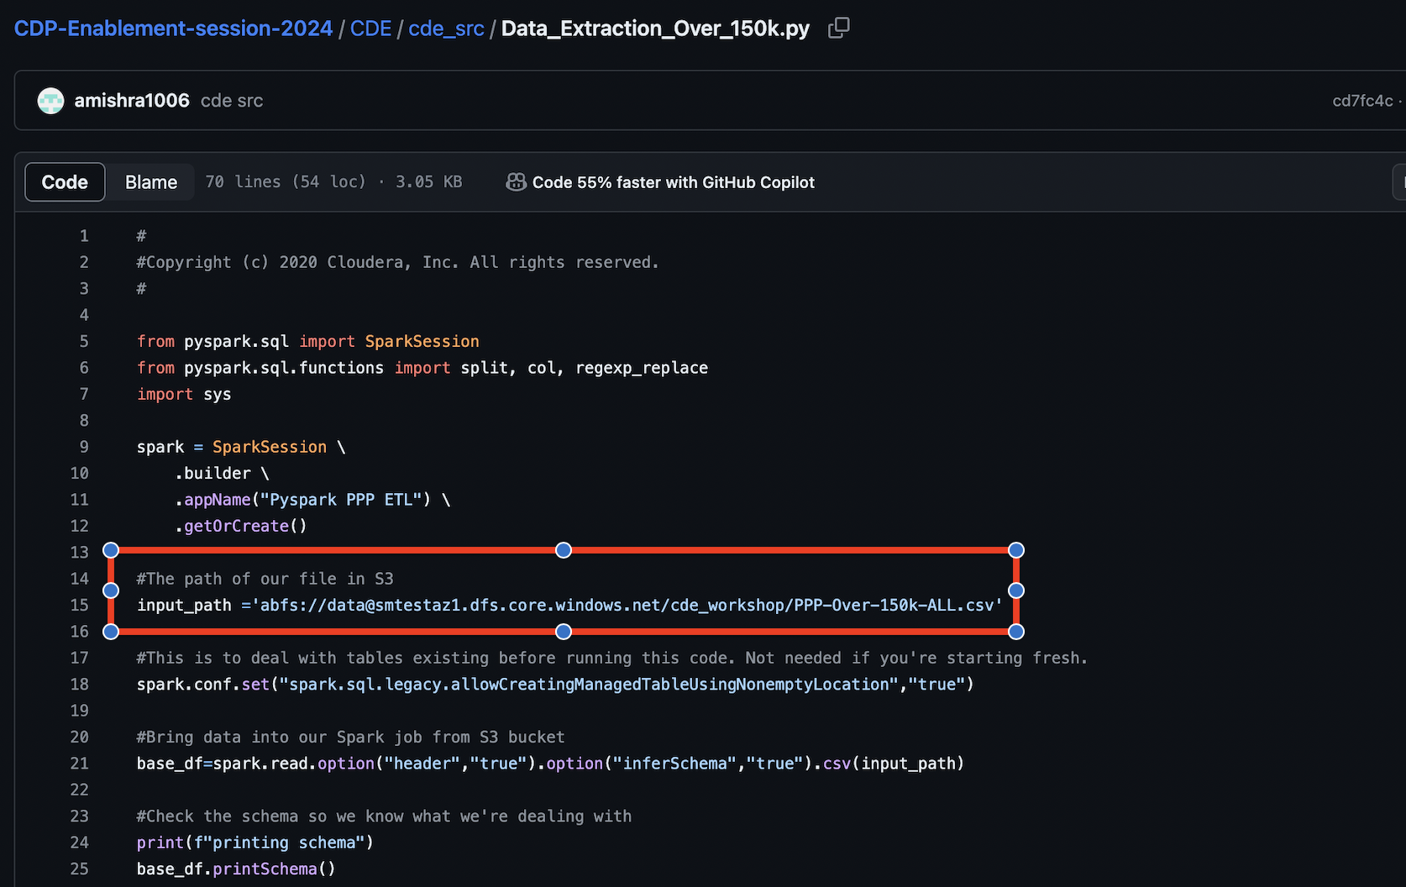

# Lab 1 - Walkthrough of CDE Data Service

Cloudera Data Engineering (CDE) is a serverless service for Cloudera Data Platform that allows you to submit jobs to auto-scaling virtual clusters.

The CDE service involves several components: **● Environment**

○ A logical subset of your cloud provider account including a specific virtual network.

* **CDE Data Service**
  1. The long-running Kubernetes cluster and services that manage the virtual clusters. The CDE service must be enabled in an environment before you can create any virtual clusters. **● Virtual Cluster**

○ An individual auto-scaling cluster with defined CPU and memory ranges. Virtual Clusters in CDE can be created and deleted on demand. Jobs are associated with clusters.

* **Job**
  1. Application code along with defined configurations and resources.

Jobs can be run on demand or scheduled. **● Resource**

○ A defined collection of files such as a Python file or application JAR, dependencies, and any other reference files required for a job.

* **Job run**
  1. An individual job run.

The above components can be accessed in the following ways:

* Go to the CDP console and click on Data Engineering.

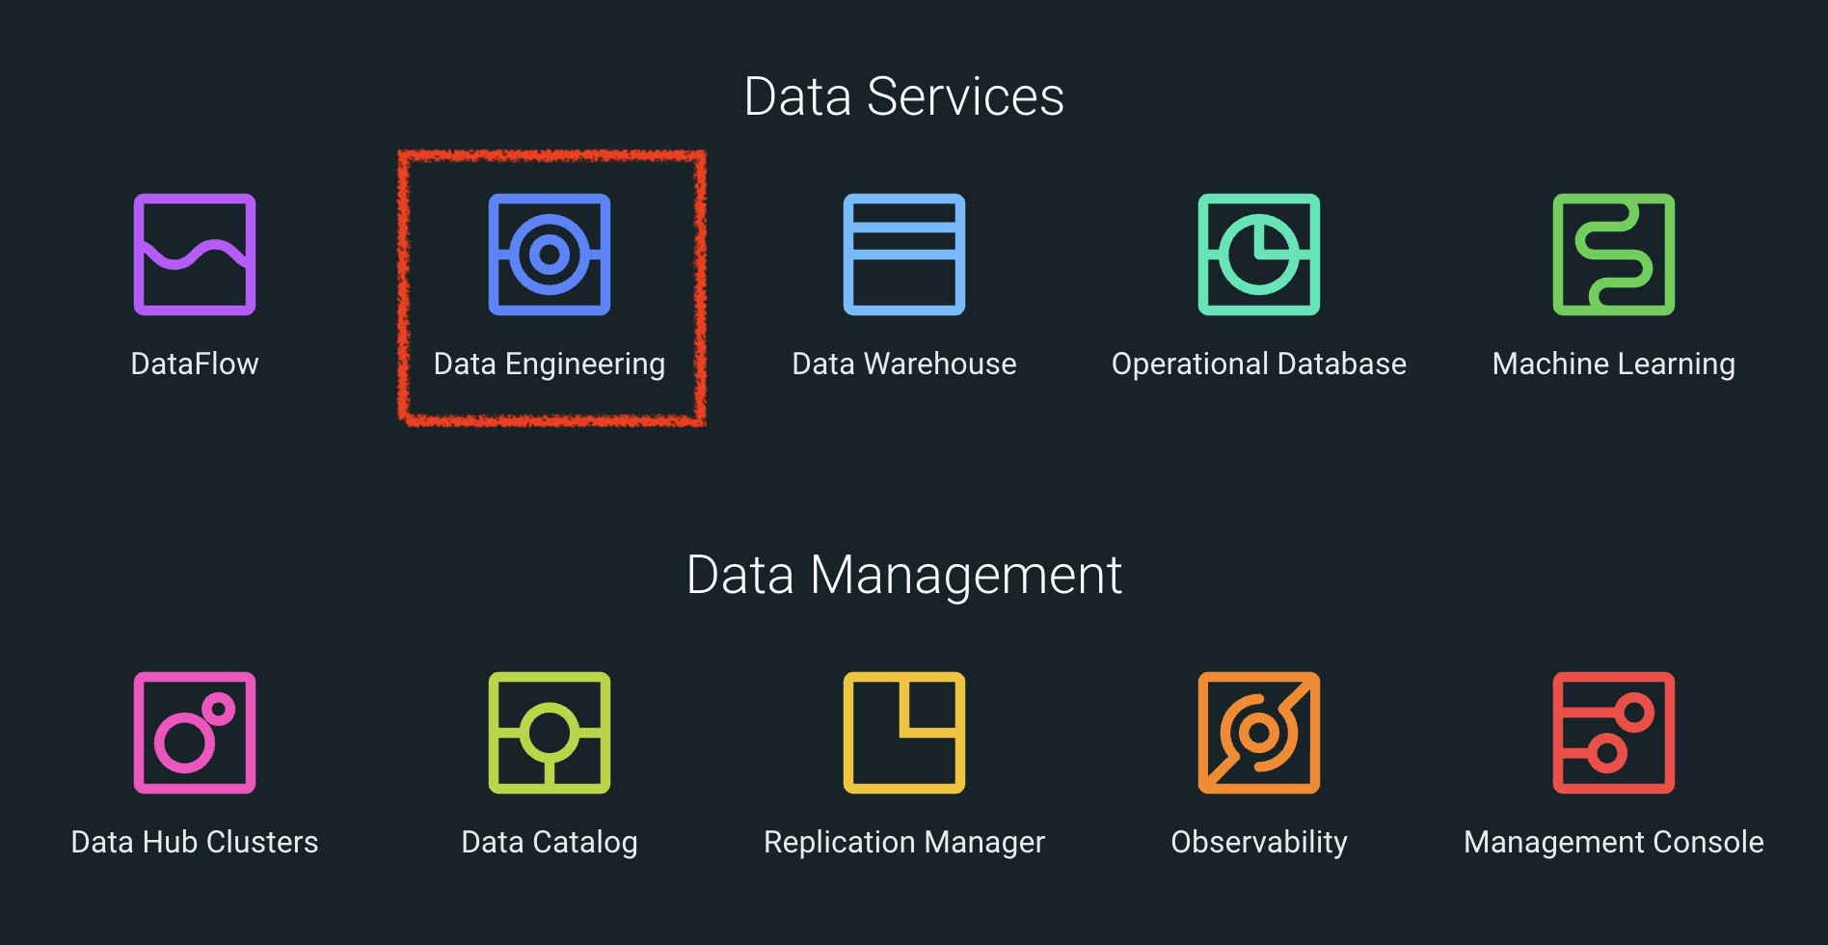

* You will see the CDE homepage.

*Note : If the page load takes a while, you can move to the next step, we can come back to this later*

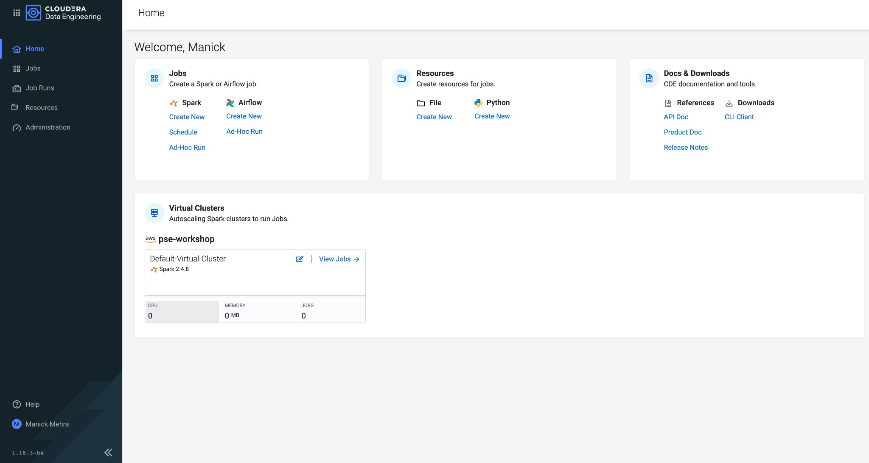

* We should have a CDE service running which we will use for this workshop. To check this Select the **ADMINISTRATION** option on the left menu on your screen. You should be able to see all the CDE Service and their status.

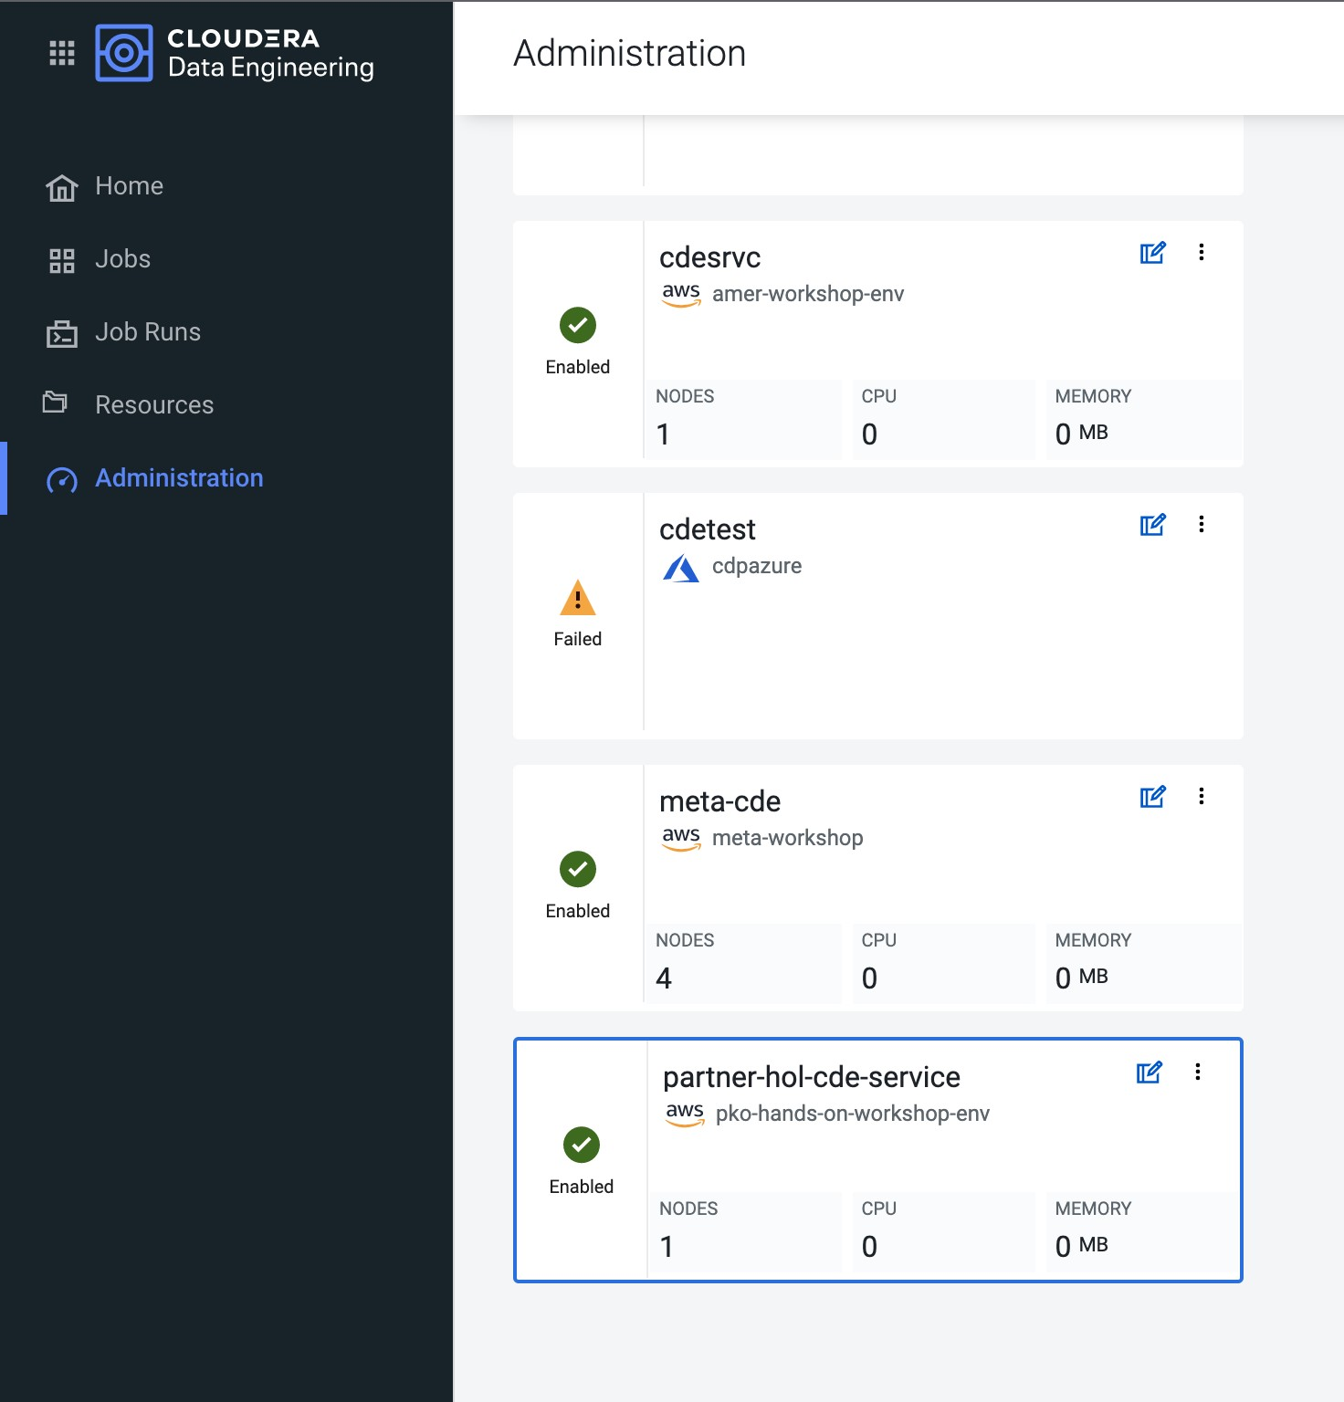

* On the **CDE service pko-workshop-cde-service,** click on the pencil icon and observe the configuration and other details related to the service.

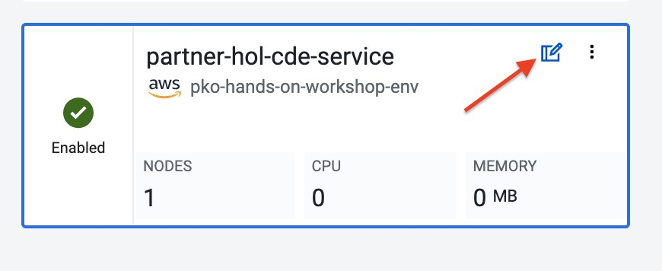

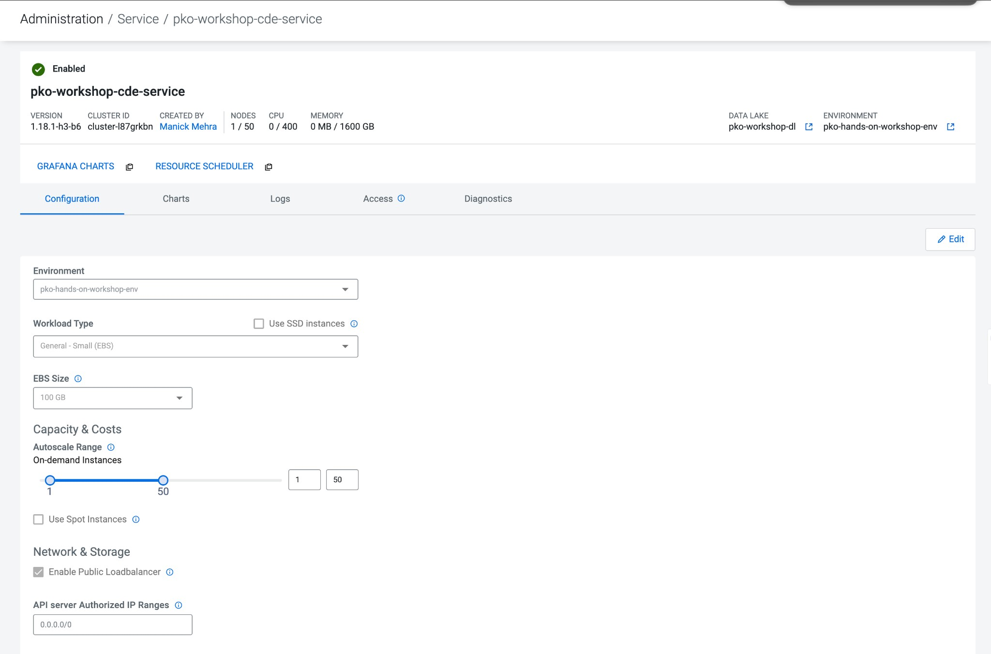

* Click on each tab and go through all the details related to the CDE service.
* Once done, click on the **Home** on the left tab to go back to the CDE home page.This page shows us the active CDE services and the associate clusters. Let’s start with accessing the virtual cluster that is assigned to you.

### ACCESSING THE VIRTUAL CLUSTER

#### Step 1 : Select the appropriate CDE Service

Go to the Administration page and select your CDE Service (In our case **partner-hol-cde-service**)

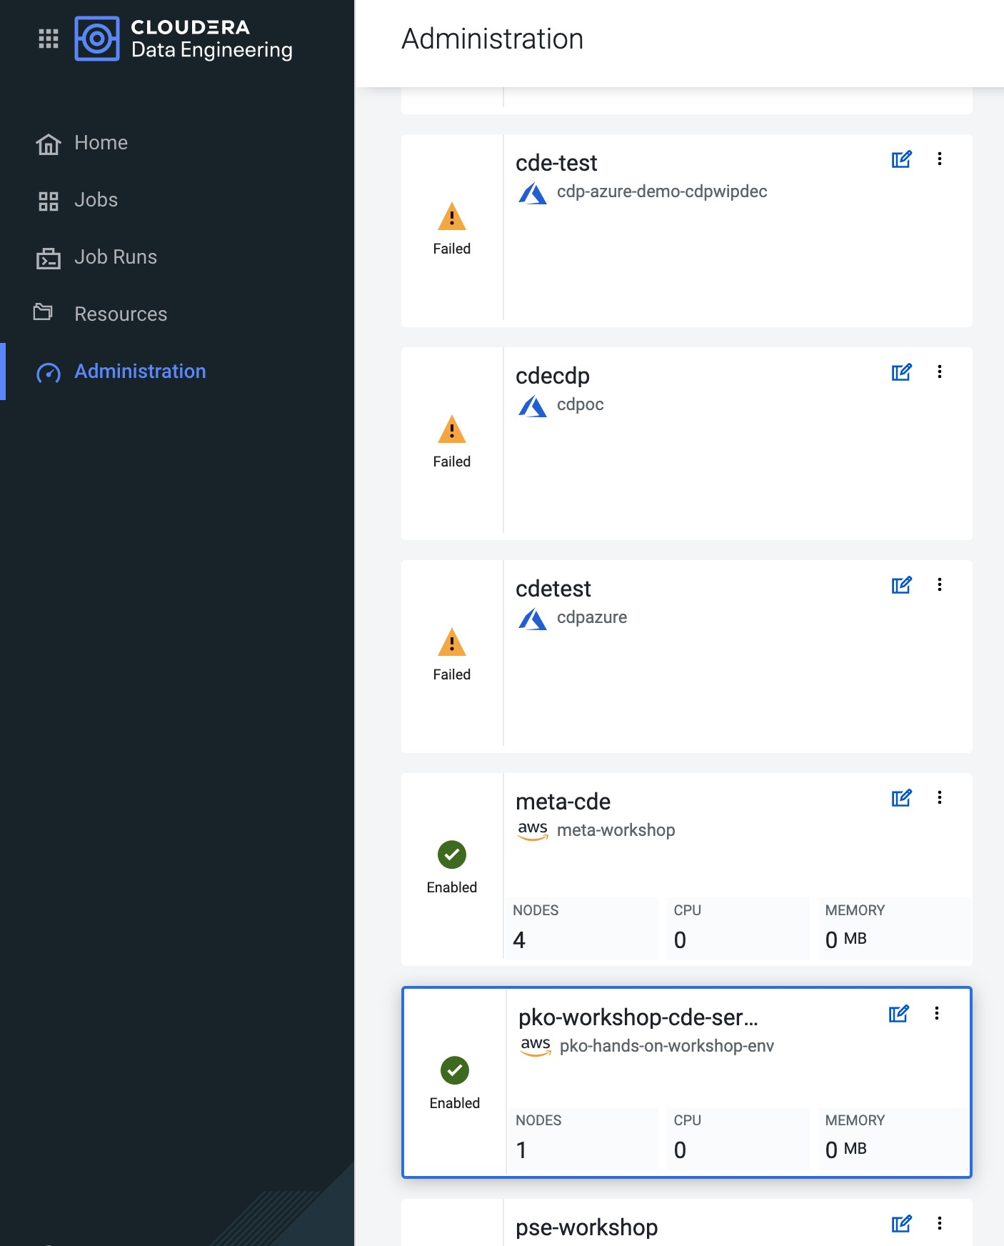

#### Step 2 : Virtual cluster selection

a. Select the CDE Service and click on the virtual cluster that was assigned to you.

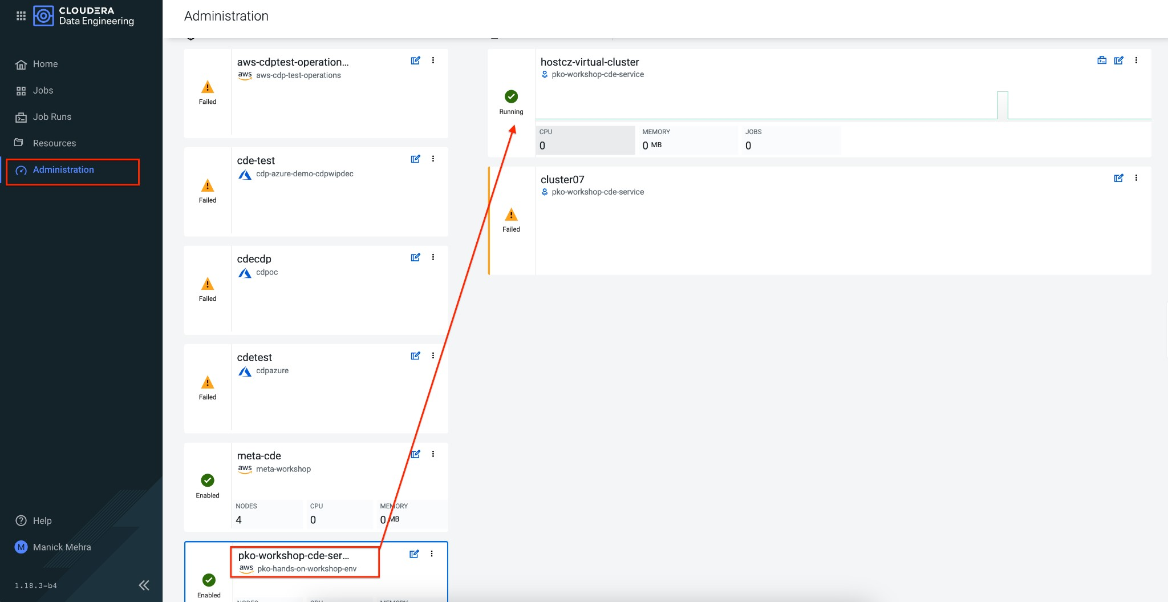

# Lab 2 - Create and trigger ad-hoc Spark jobs

In this lab, we will create spark jobs and run them on an ad-hoc basis, i.e., without any schedule. As part of this lab, we have taken two simple use-cases that can be addressed with the help of Spark jobs.

## Resource Creation

* On the virtual cluster **Cluster Name** : *<username>-virtual-cluster* [ Virtual cluster created in Lab 1] tab**,** click on view jobs. This will open a new page with details of the Job Runs, Jobs, and Resources.

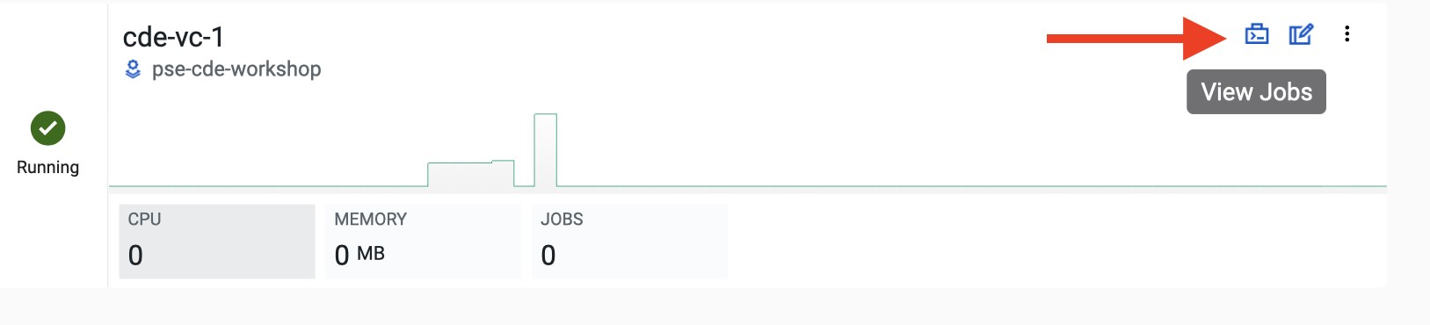

* In the left pane, click on the **Resources** tab.

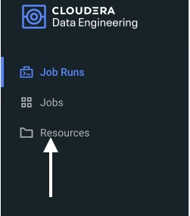

* You will get the **Resources** page to the right. Click on **Create Resource**.



* Give a unique name(username-resources) and create the resource. This acts as your repository for storing all the scripts and dependencies.
* Once it is created, you will get an option to upload the files as shown below.

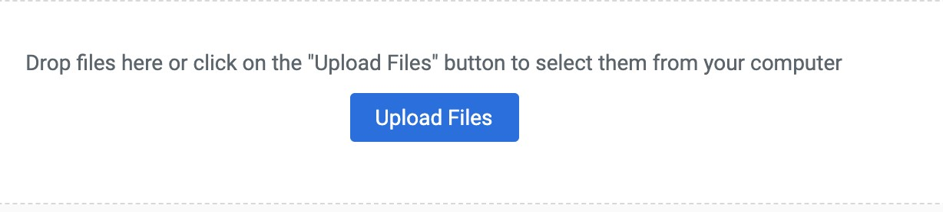

* Click on **Upload Files** and select all the scripts downloaded from the prerequisites step.

(**Please upload only .py files**). Click on Upload

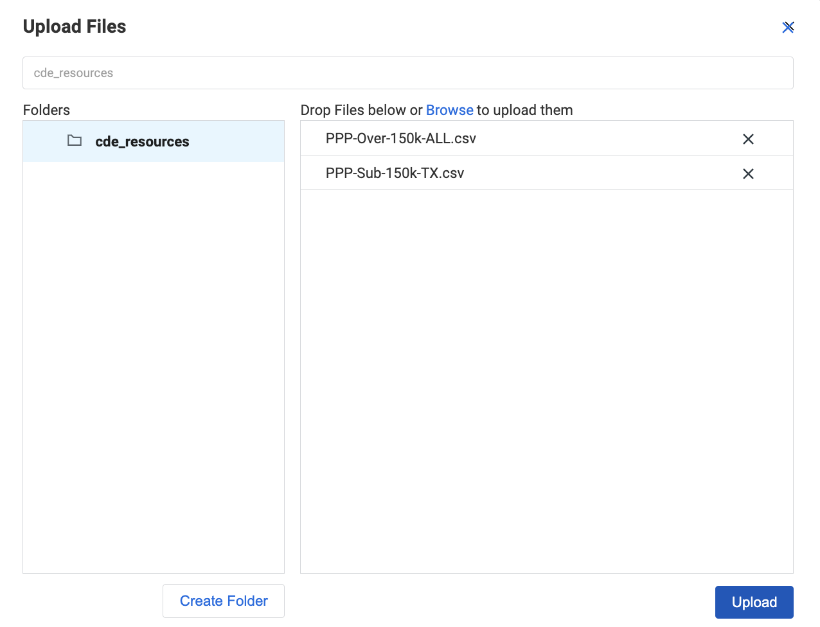

* Validate if both *.py* files are present in your resource. We are now ready to create jobs using these resources.

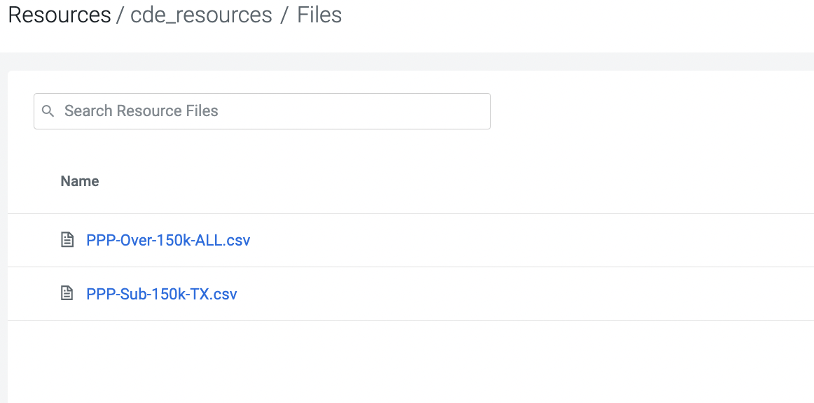

## Job Creation

* We will now create the first job
* In the left pane, click on **Jobs.**
* You will get the **Jobs** page to the right. Click on **Create Job**.

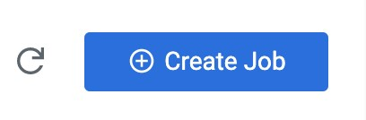

* Select job type as **Spark**.
* Please give the job names as mentioned below.

*<username>_<script_name_without_py_extension>*

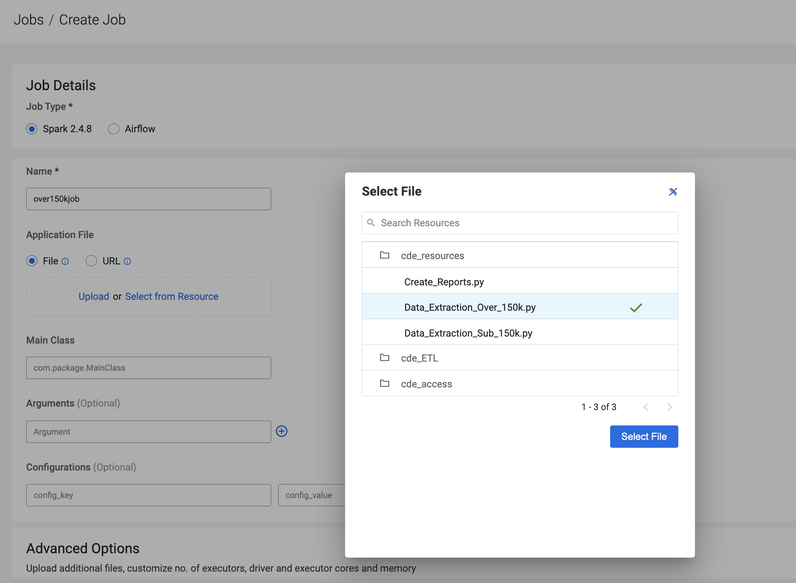

Click create Job for one by one for all 3 .py files

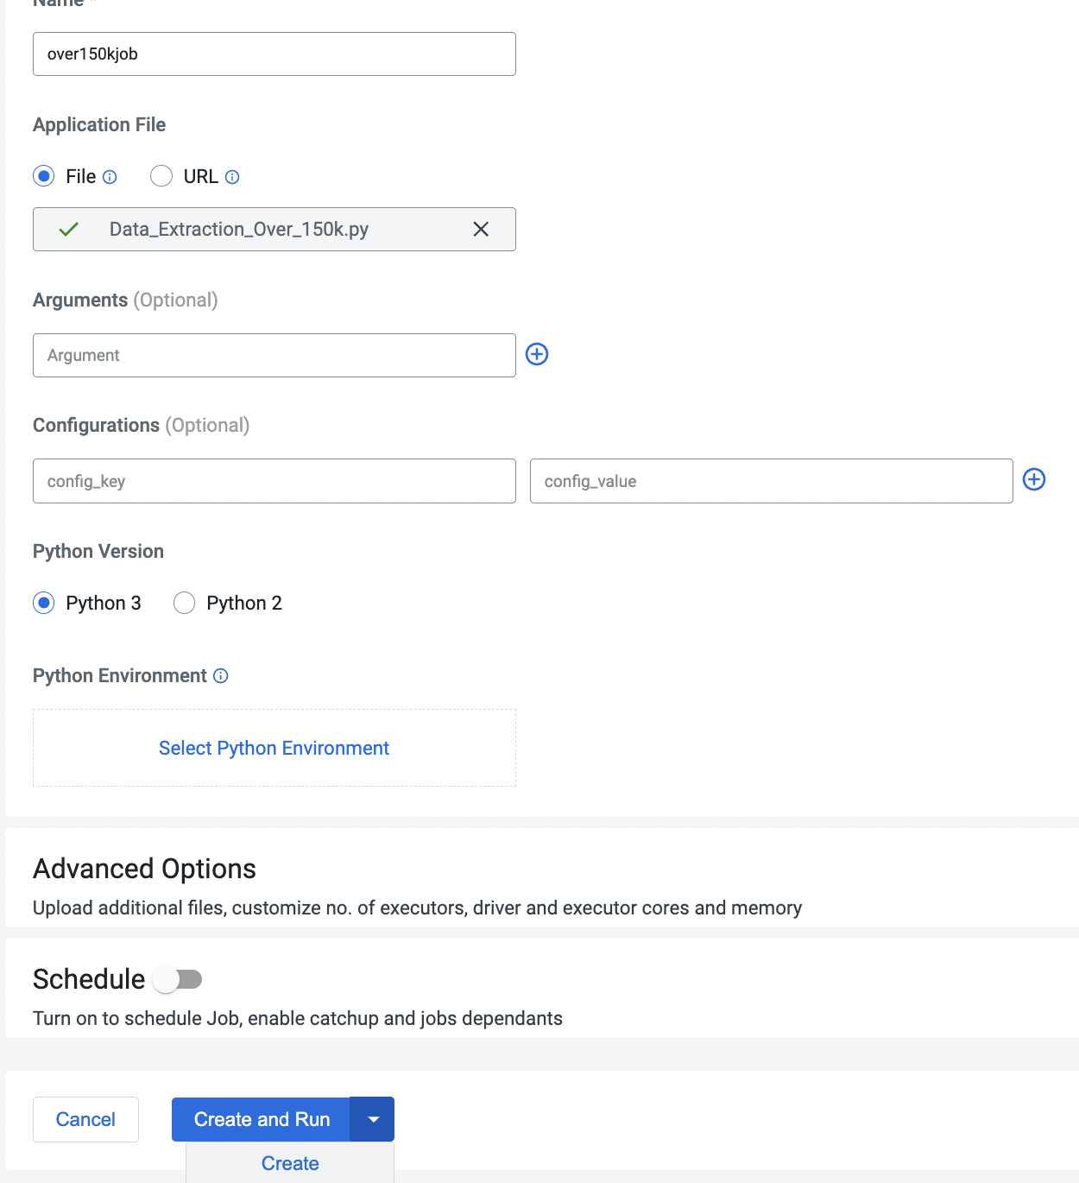

* Once the Job is created run them one by one from UI under jobs tab

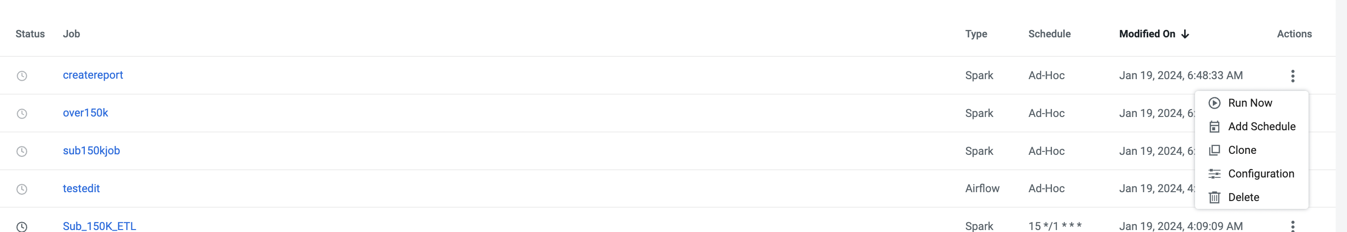

* Trigger Jobs one by one Sub15k, Over 15k , create report and check the status of Job from Job run

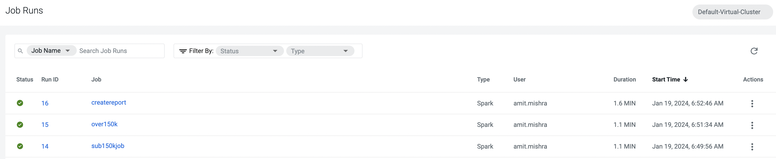

* Monitor the Job runid and verify logs for any failure or data loaded successfully

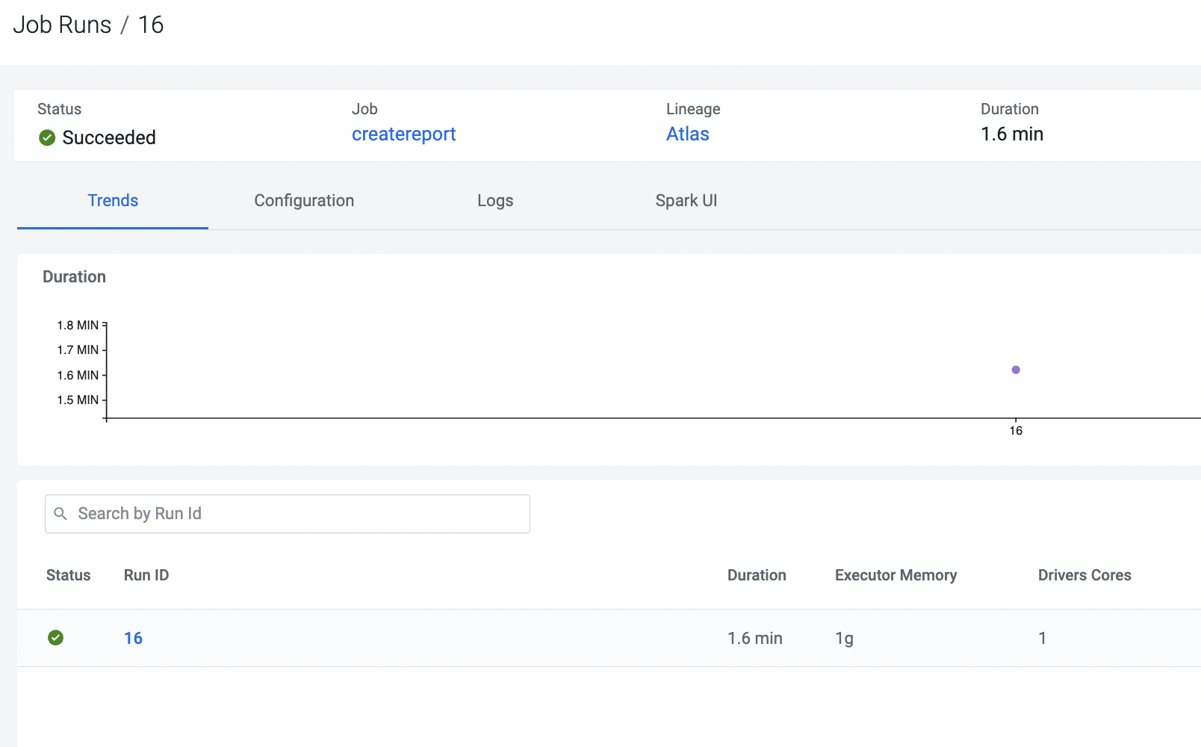

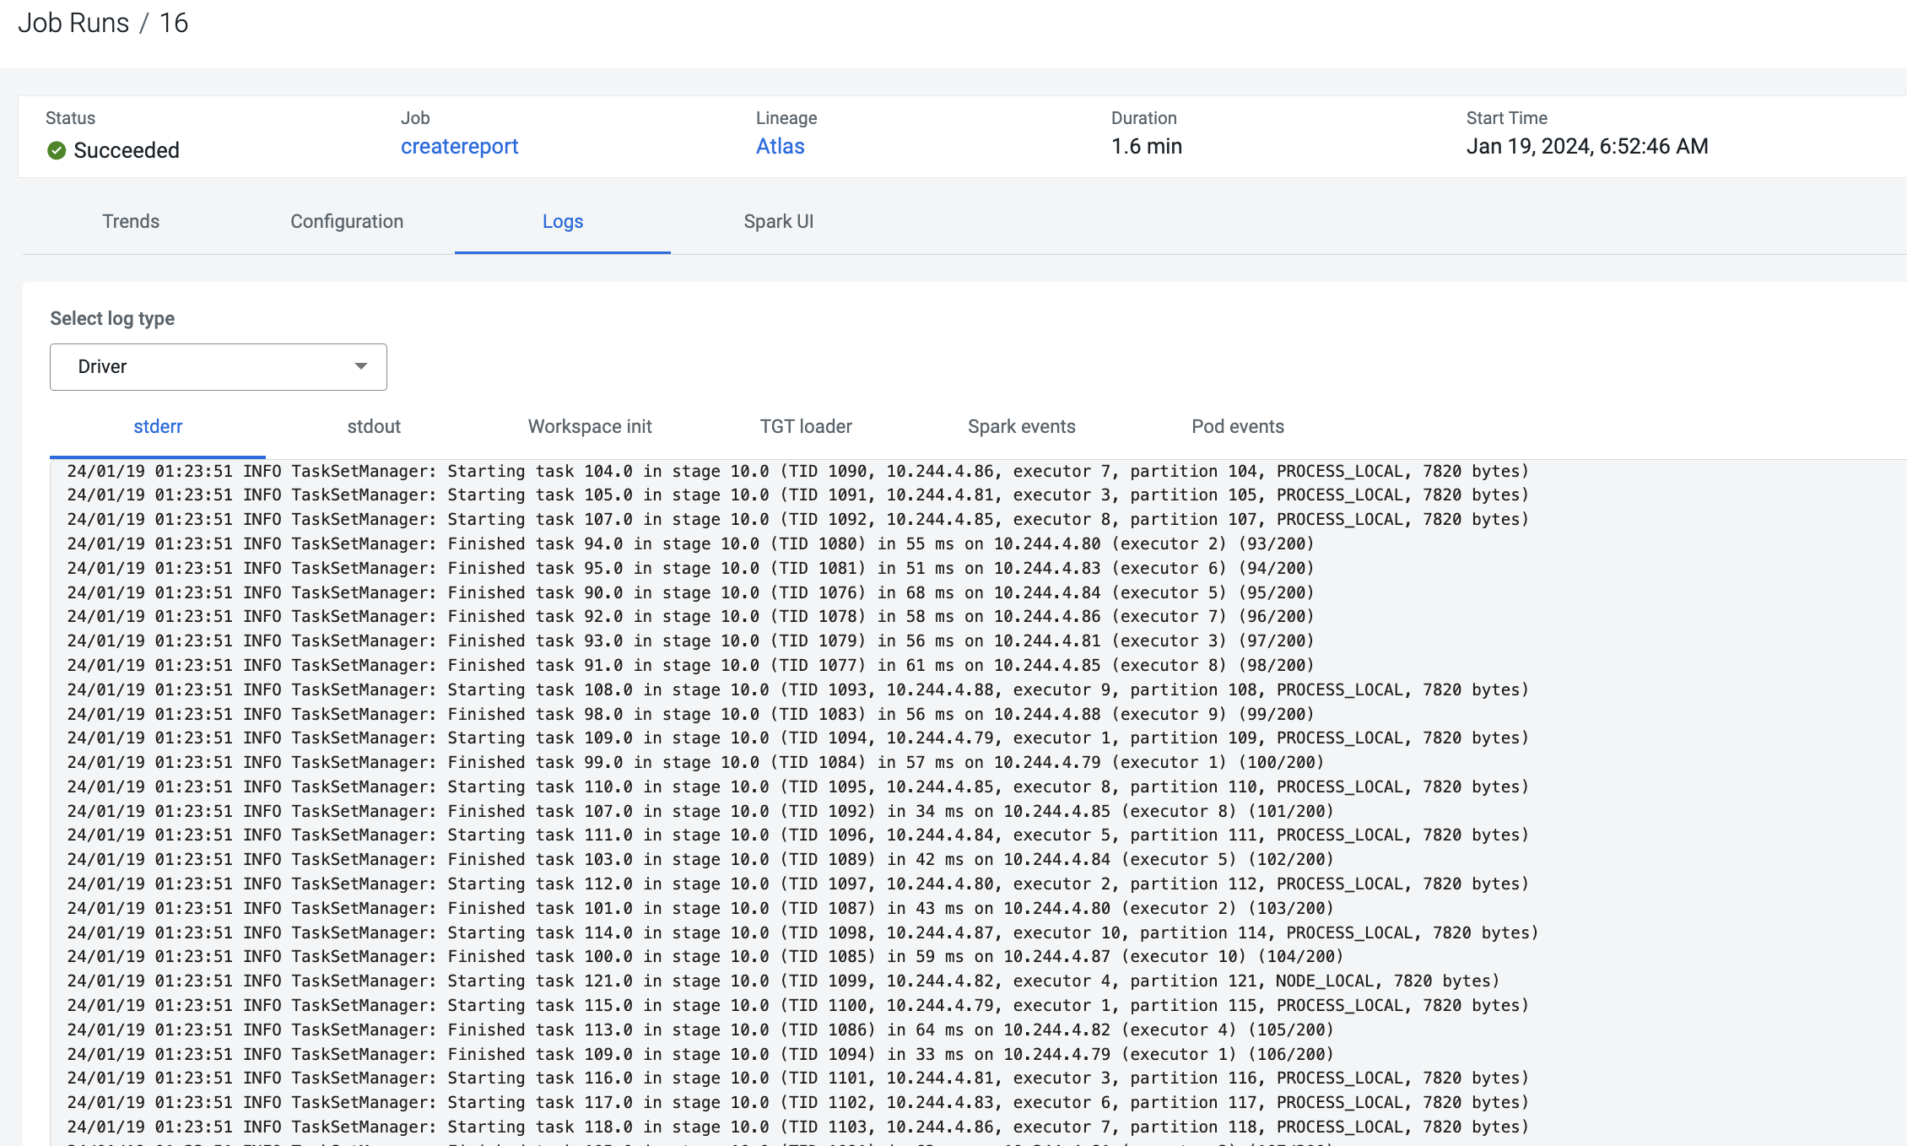

Monitor The job execution from spark UI by clicking spark UI from previous screen

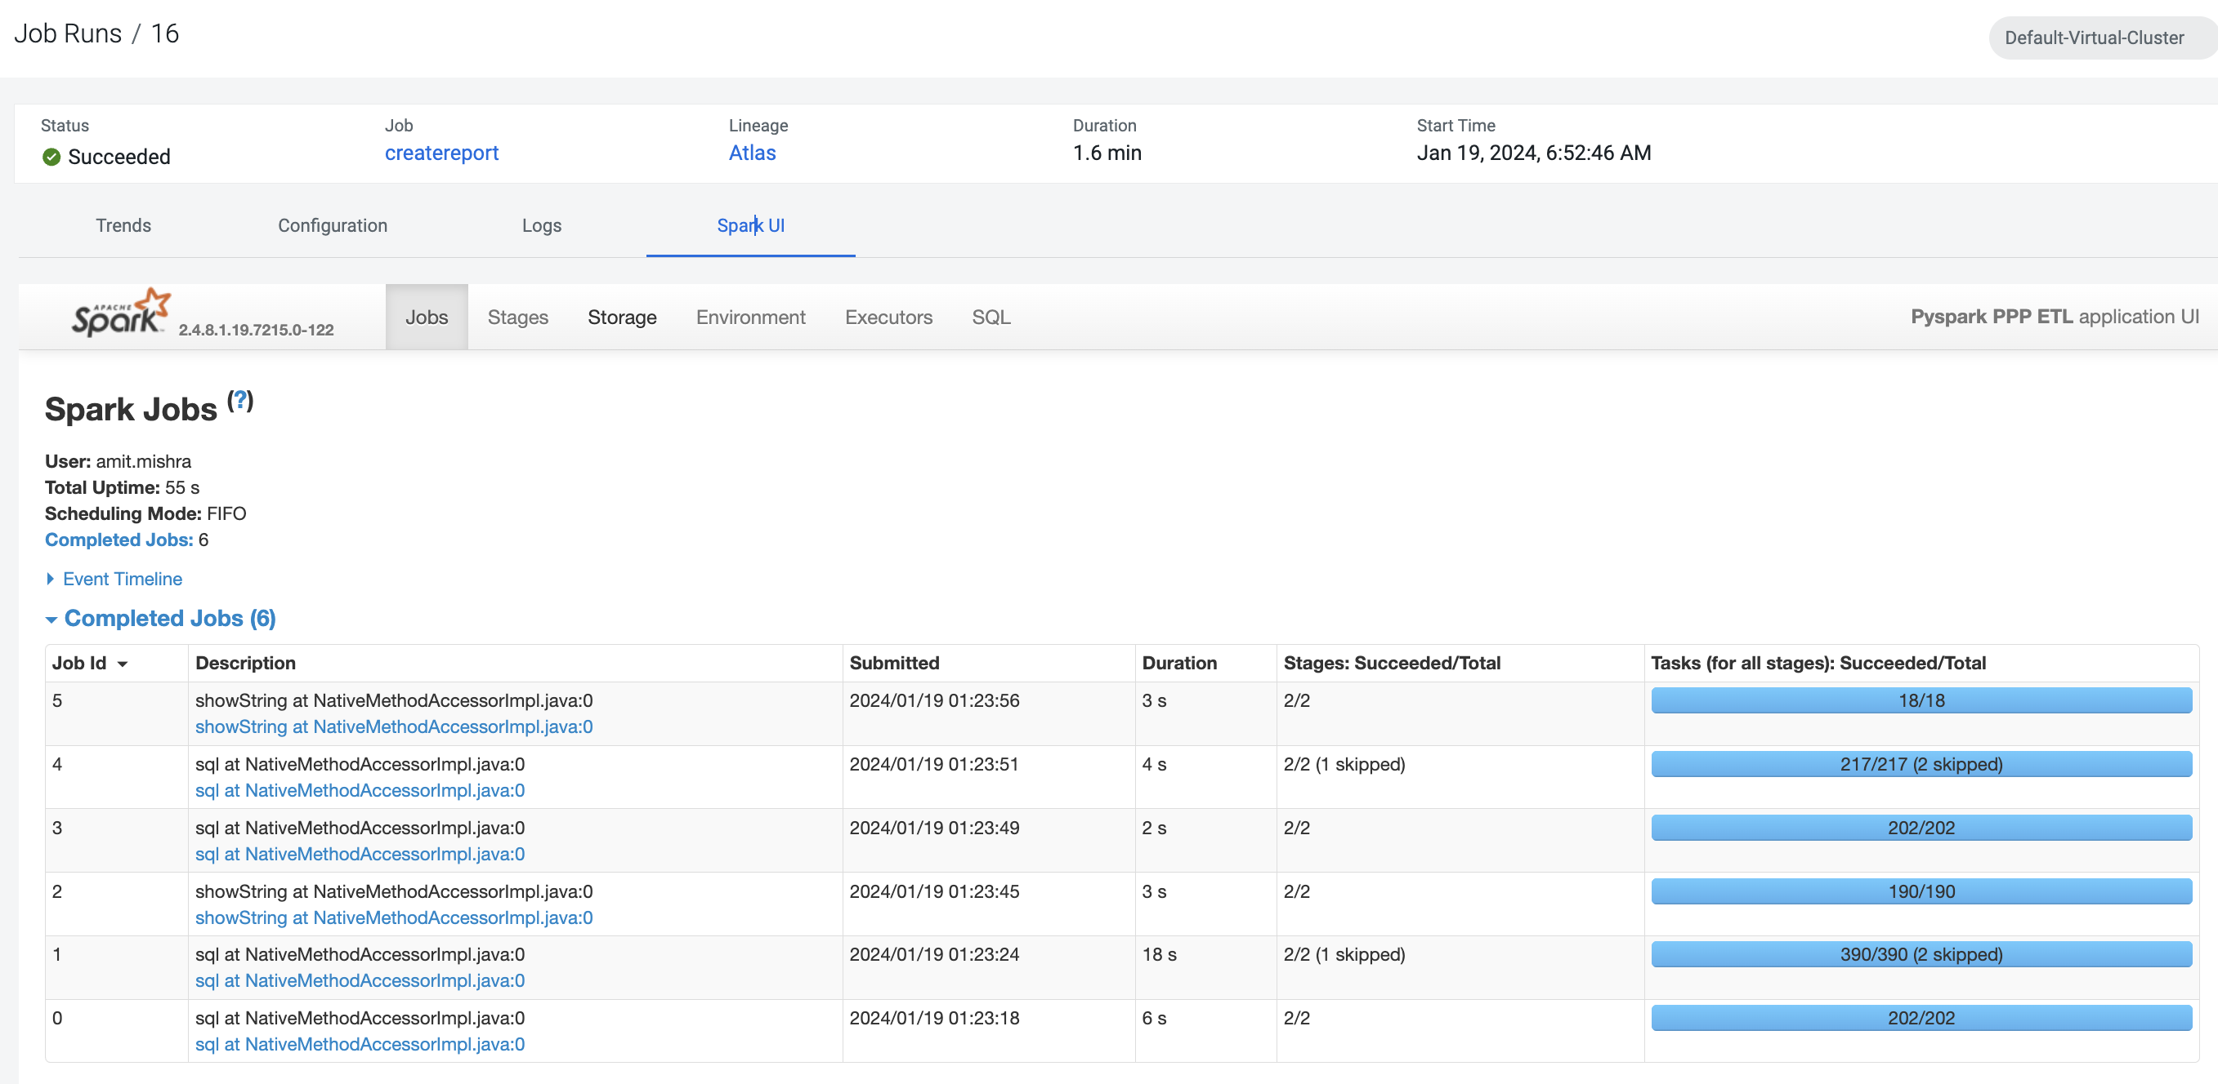

# Lab 3 - Add schedule to the ad-hoc Spark jobs

In this lab, we will add a schedule to a job created as part of the previous lab.

* We will add a schedule to the job **Lab3A_access_logs_ETL**

**(**in your case it will be <username>_Lab3A_access_logs_ETL)

* Go to **Jobs** tab, click on the 3-dotted icon next to the job **createreport job** and select **Add schedule**.

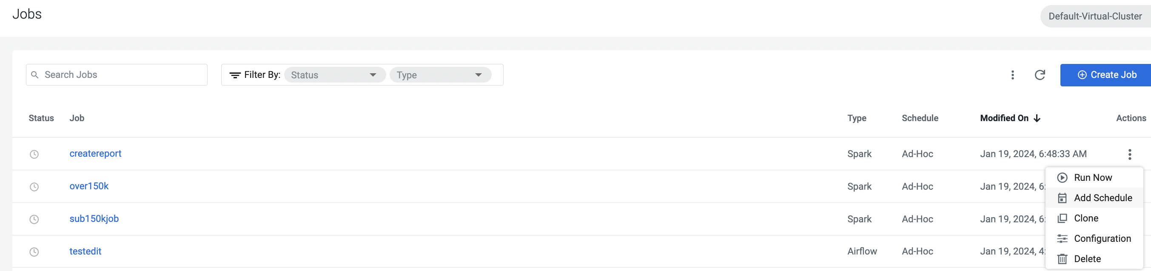

* You will land in the **Job Schedule** page. Click on **Create a Schedule**.

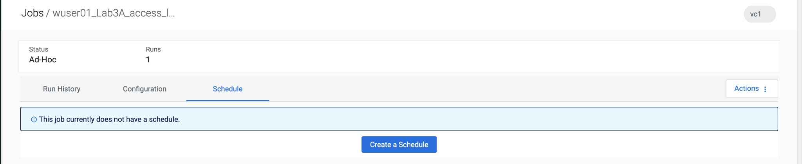

* Choose the **Cron Expression** option and enter the cron expression as given below.

**\*/10 * * * \*** → This means that the job is scheduled to run every 10 minutes.

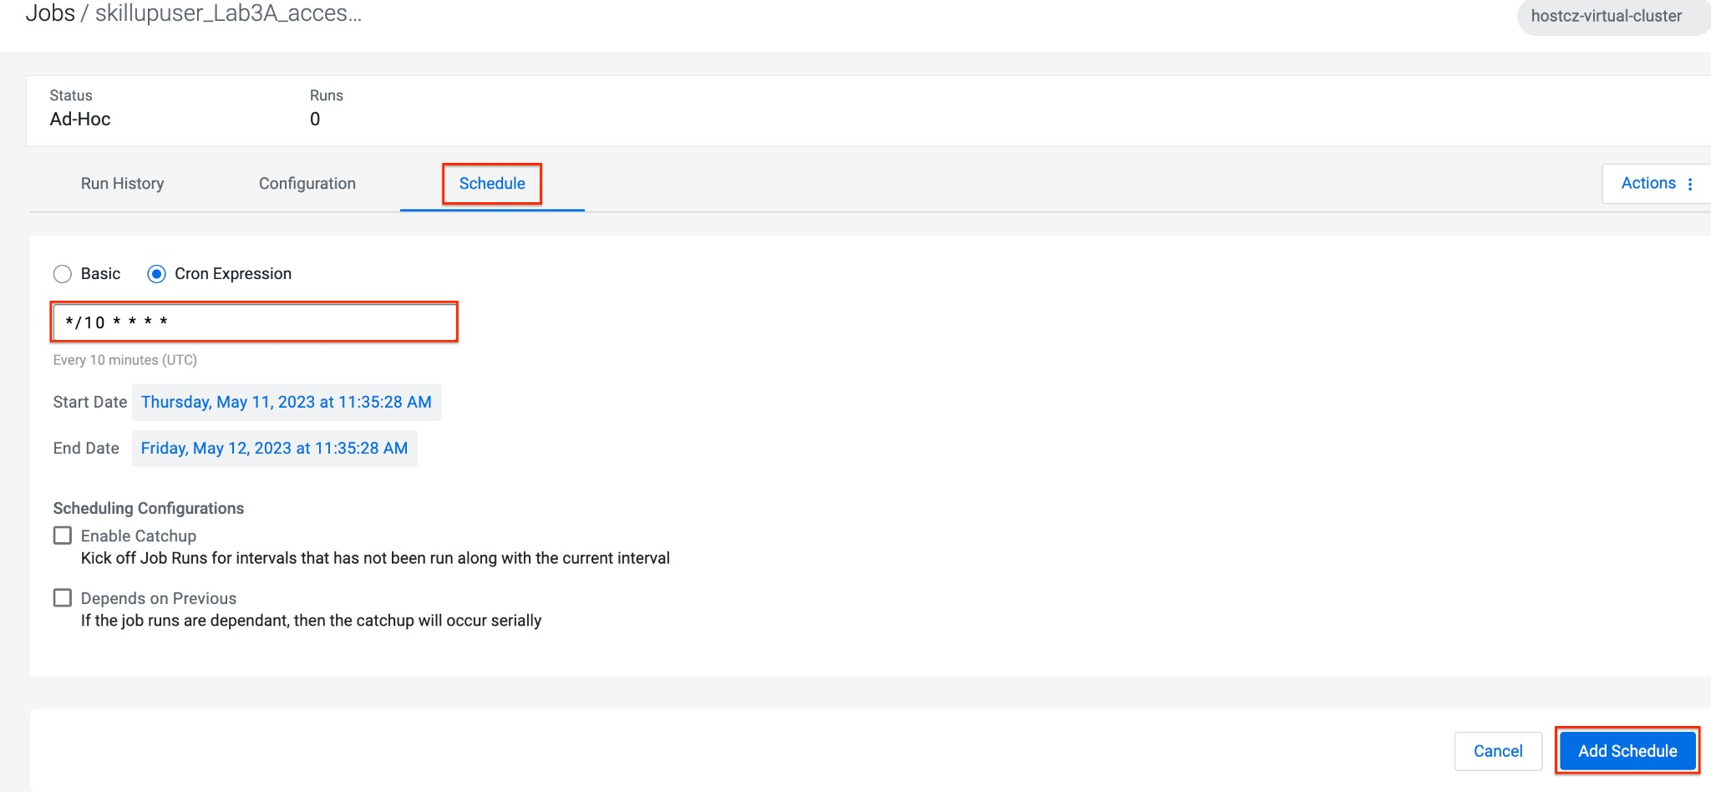

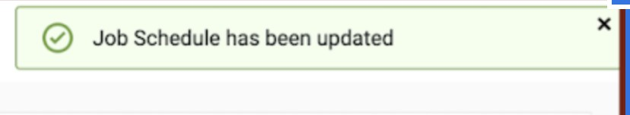

* You can repeat the same process for the other jobs as well.

JOB 1 : Run every 10 mins

JOB 2 : Run every 10 mins

JOB 3 : Run every 10 mins

JOB 4 : Run every 30 mins

* We do not have to wait for the jobs to get triggered as per the schedule. The idea was to understand how Ad-Hoc jobs are scheduled. We can continue with the next steps
* **Please PAUSE the schedule for all the jobs for which it was added by following the below steps.**
* Go to the Jobs tab, click on the 3-dotted icon next to the job and select **Pause schedule**. [ Do this for all jobs ]

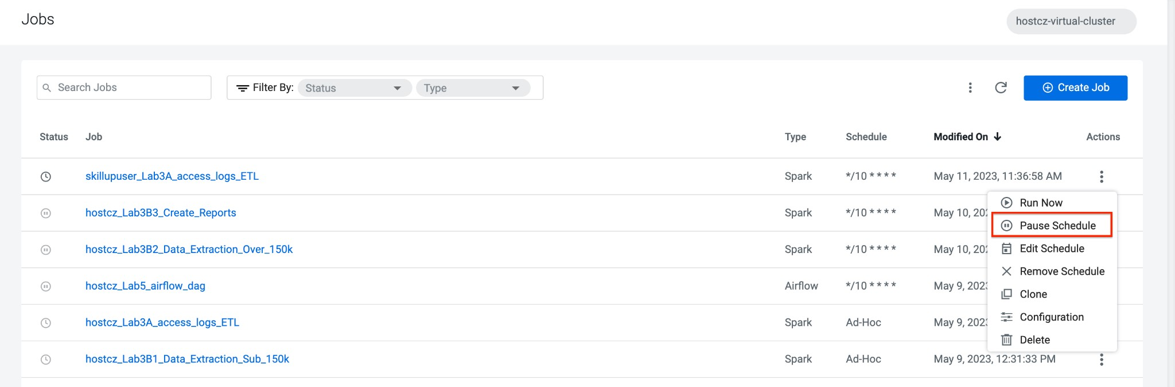

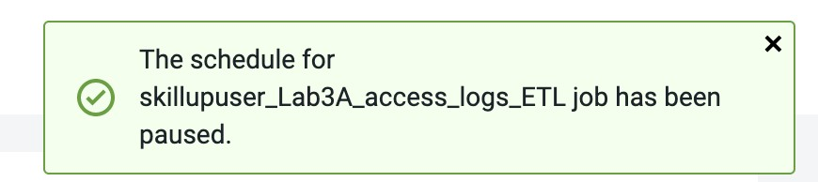

# Lab 4 - Orchestrate a set of jobs using Airflow

In this lab, we will create a flow with the help of a dag file that uses the jobs created in Lab3. Thus, you will be able to complete subsequent labs only if you have completed Lab3 successfully.

* Go to Jobs tab, click on ***Create Job*** and choose Airflow in Job type.
* Choose DAG File as Editor

JOB NAME : <username>_airflow_dag

Example : the job name will be, ***apac01_Lab5_airflow_dag***

● Click on **Create.**

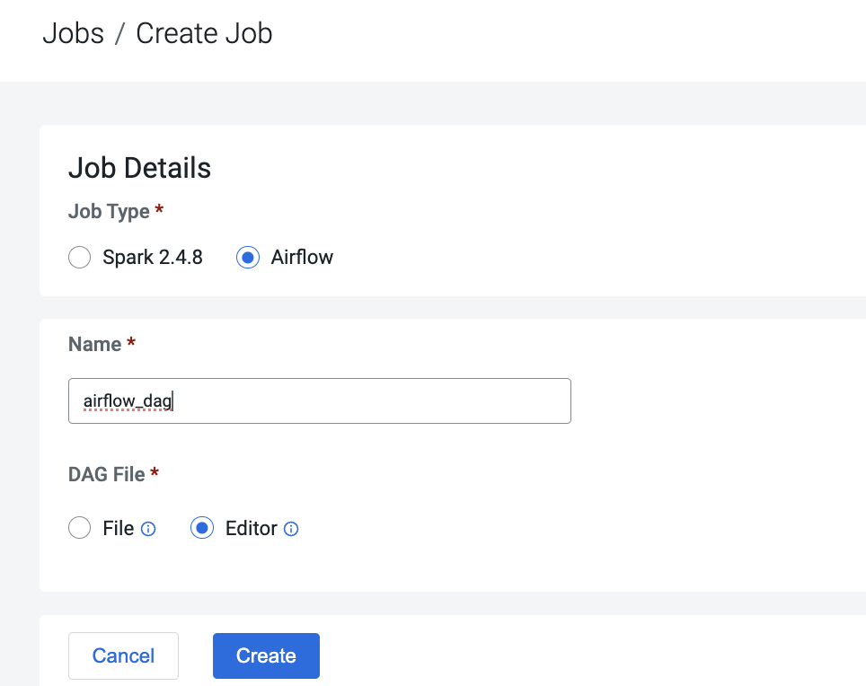

* Drag CDE Job Operator on canvas

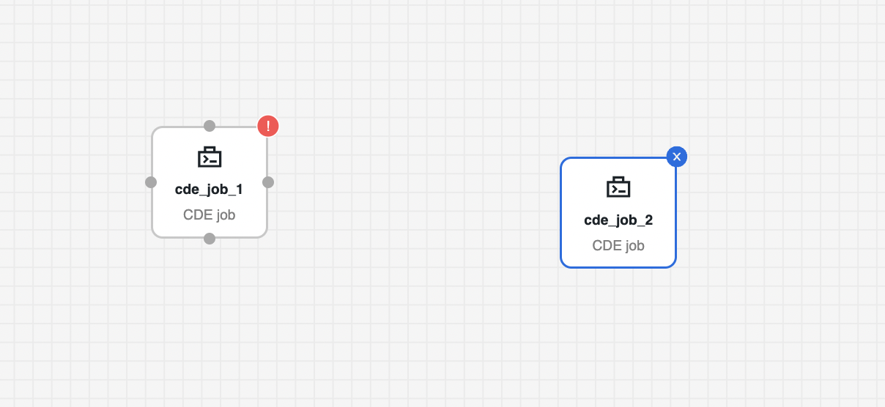

cde_job_1 – configure Job1

Select Job:- sub150kjob

Override spark Value - Yes

Argument – put your workload username

cde_job_2 – Configure Job 2

Select Job:- over150kjob

Override spark Value - Yes

Argument – put your workload username

Advance – select depend on Past

* To setup execution bind both jobs as below and click save

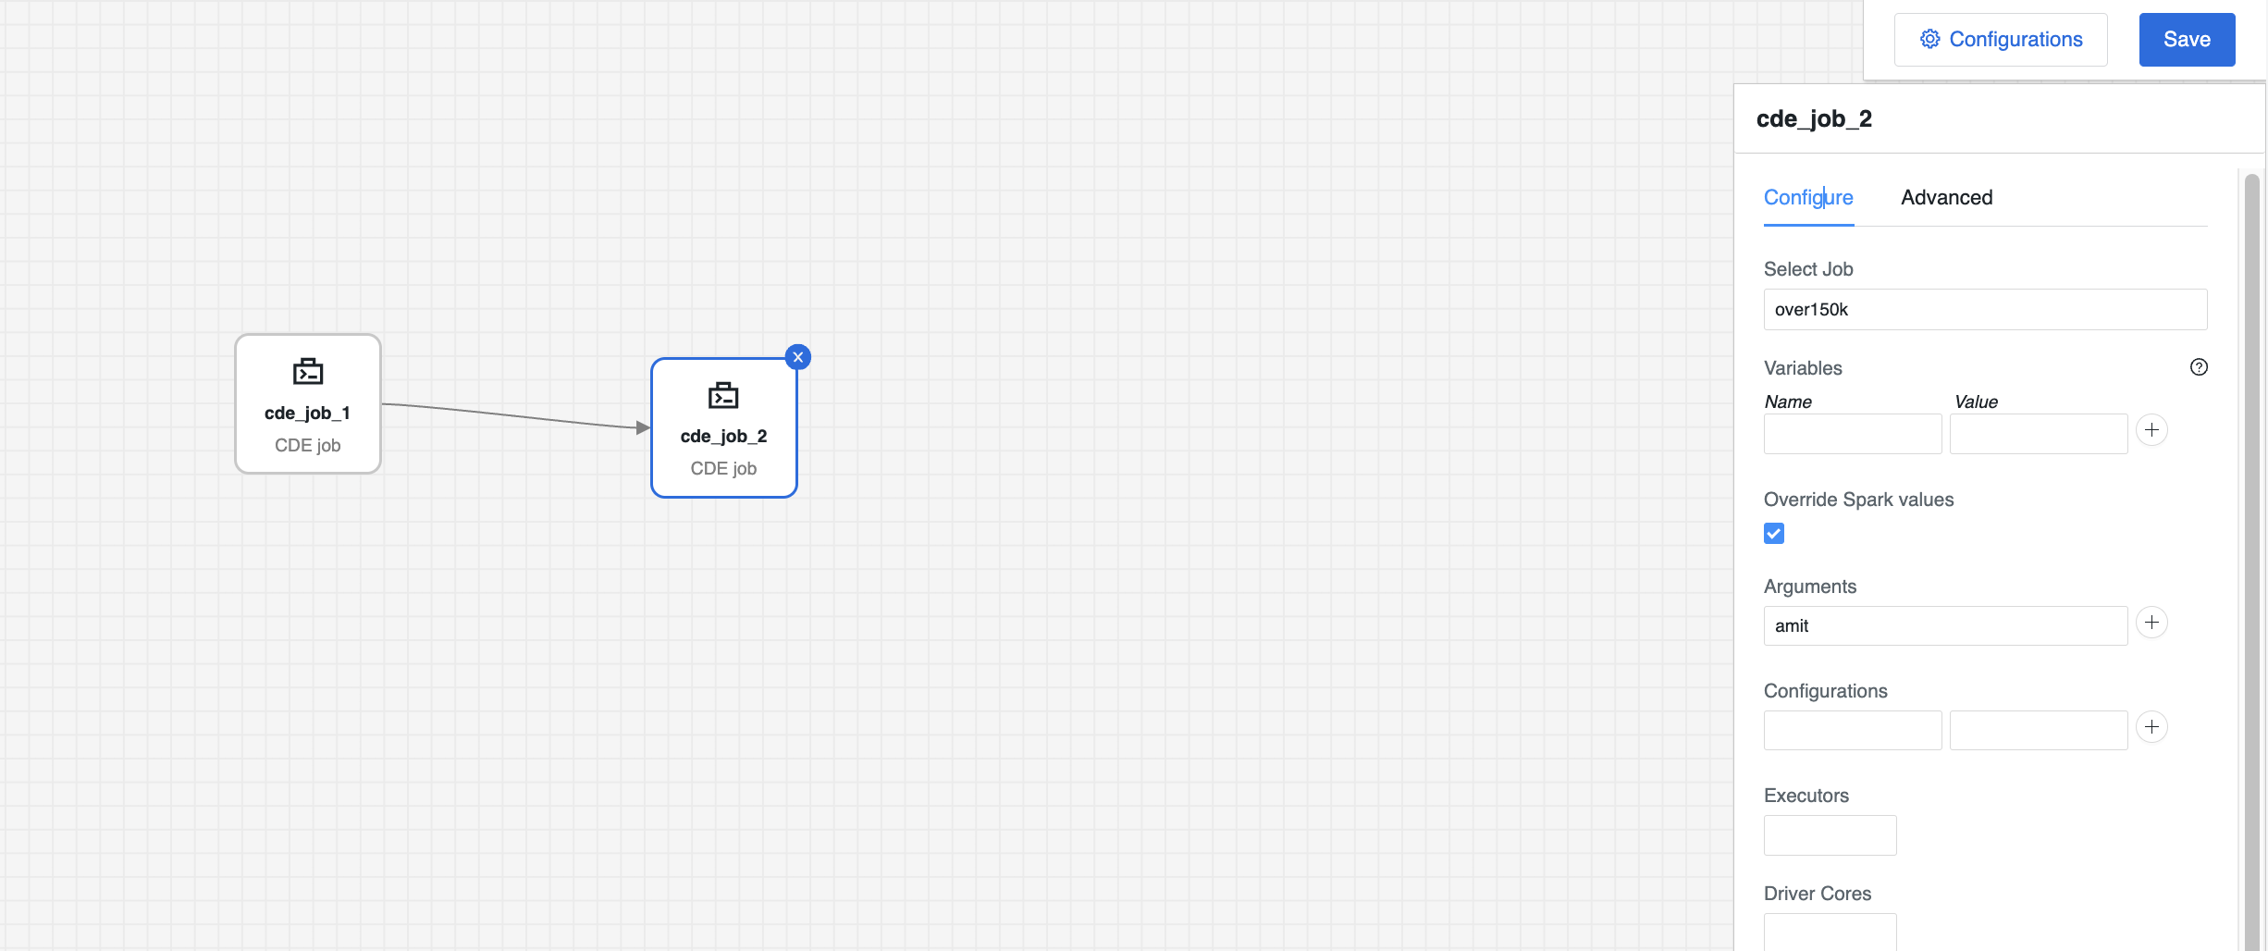

* Execute Pipeline by going to action and click Run Now

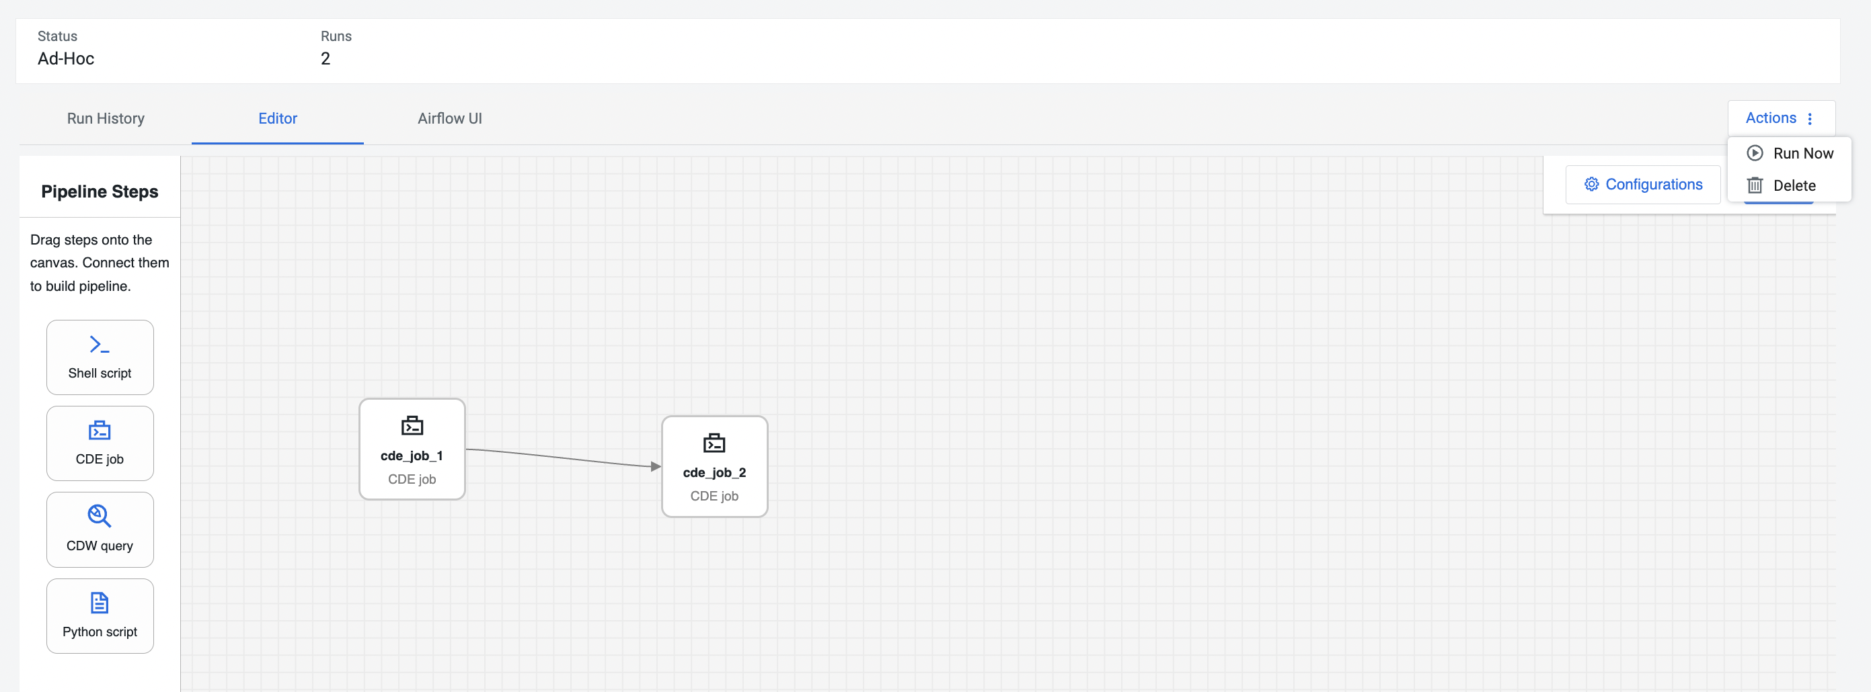

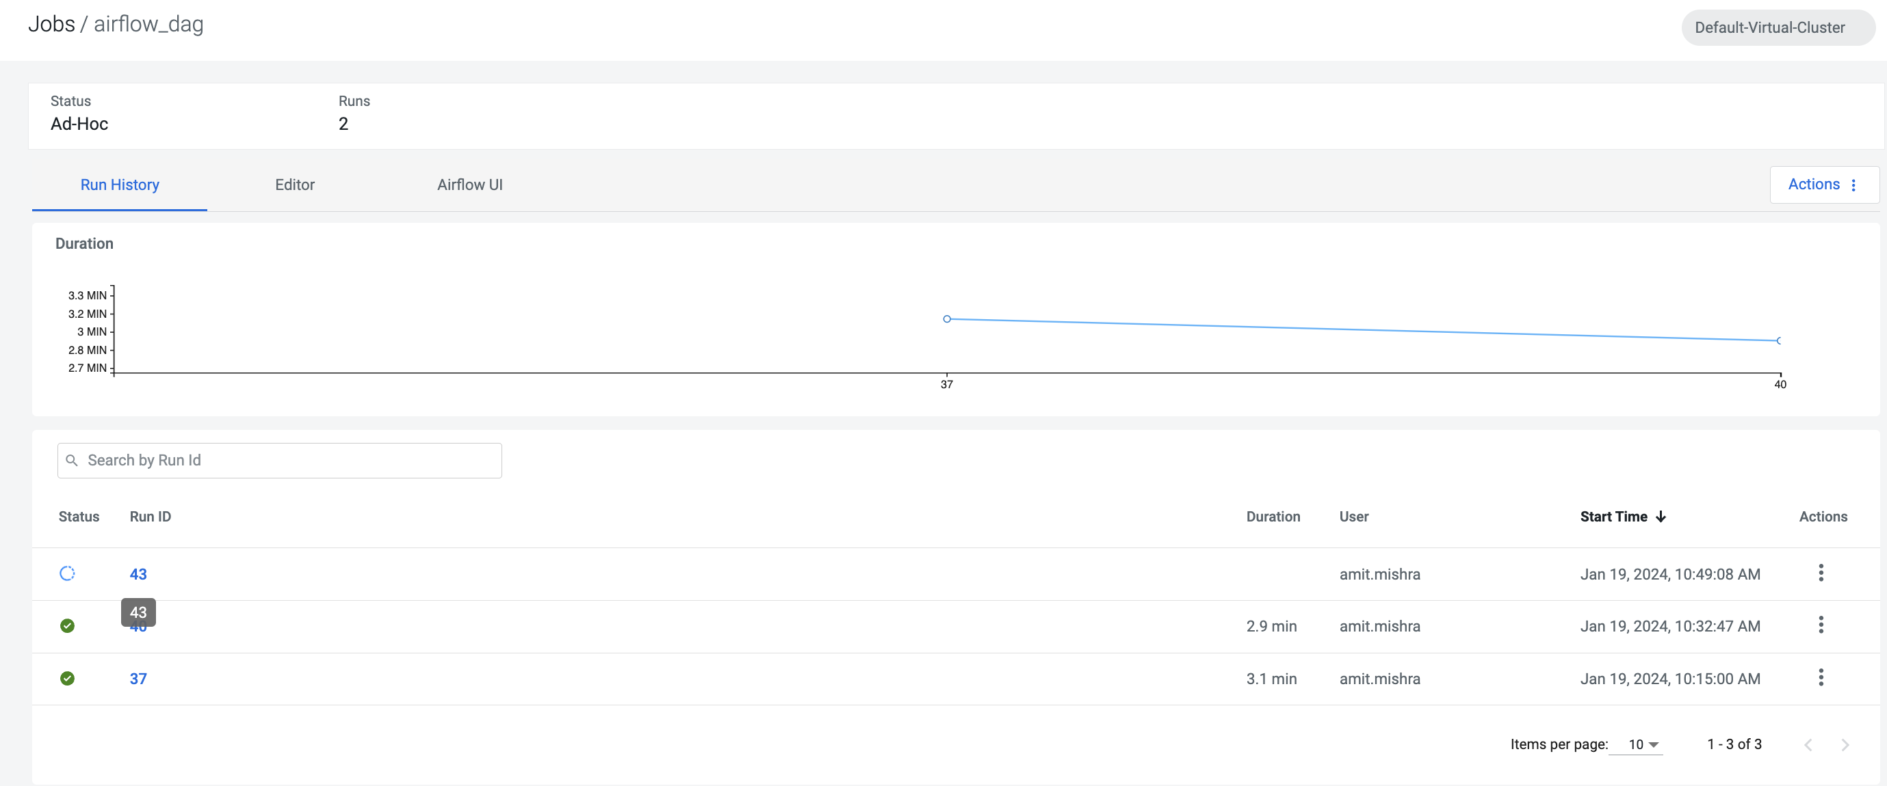

* Click on **Airflow UI** and observe the execution details of steps. Green color job is success

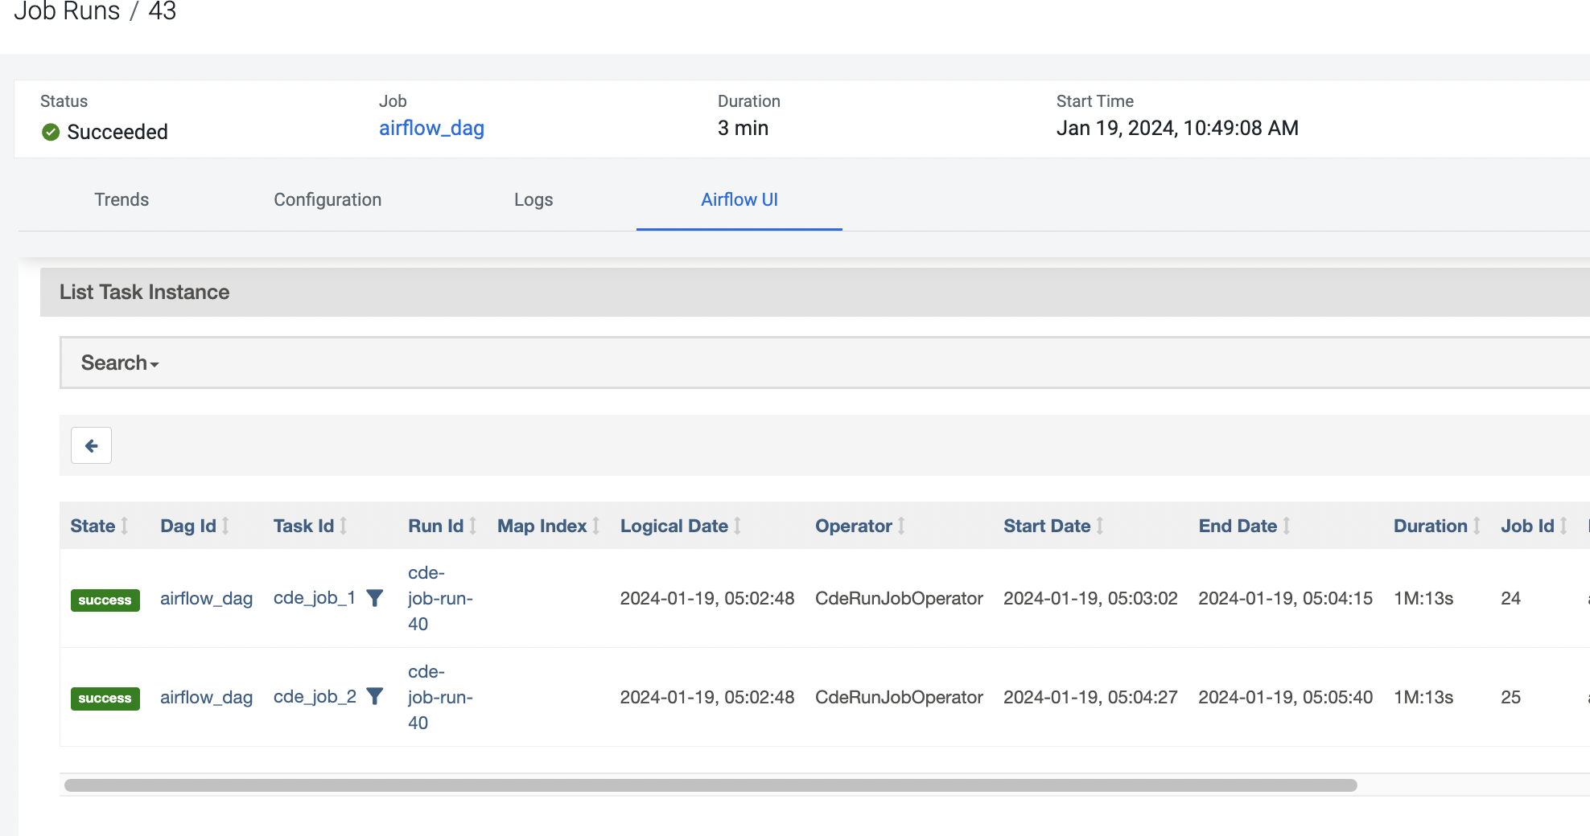

* Click on **Airflow dag** and observe the both operator ran successfully

